 

Placement Empowerment Program

***Cloud Computing and DevOps Centre***

BUILD AND RUN A CUSTOM DOCKER IMAGE

NAME:AXSHLIN SHARMIL S

DEPT:CSE

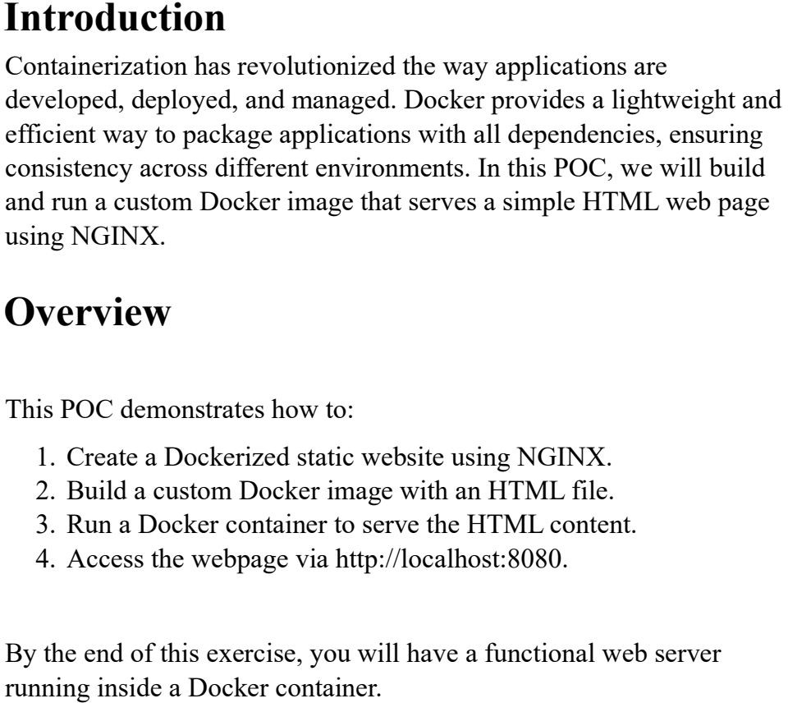

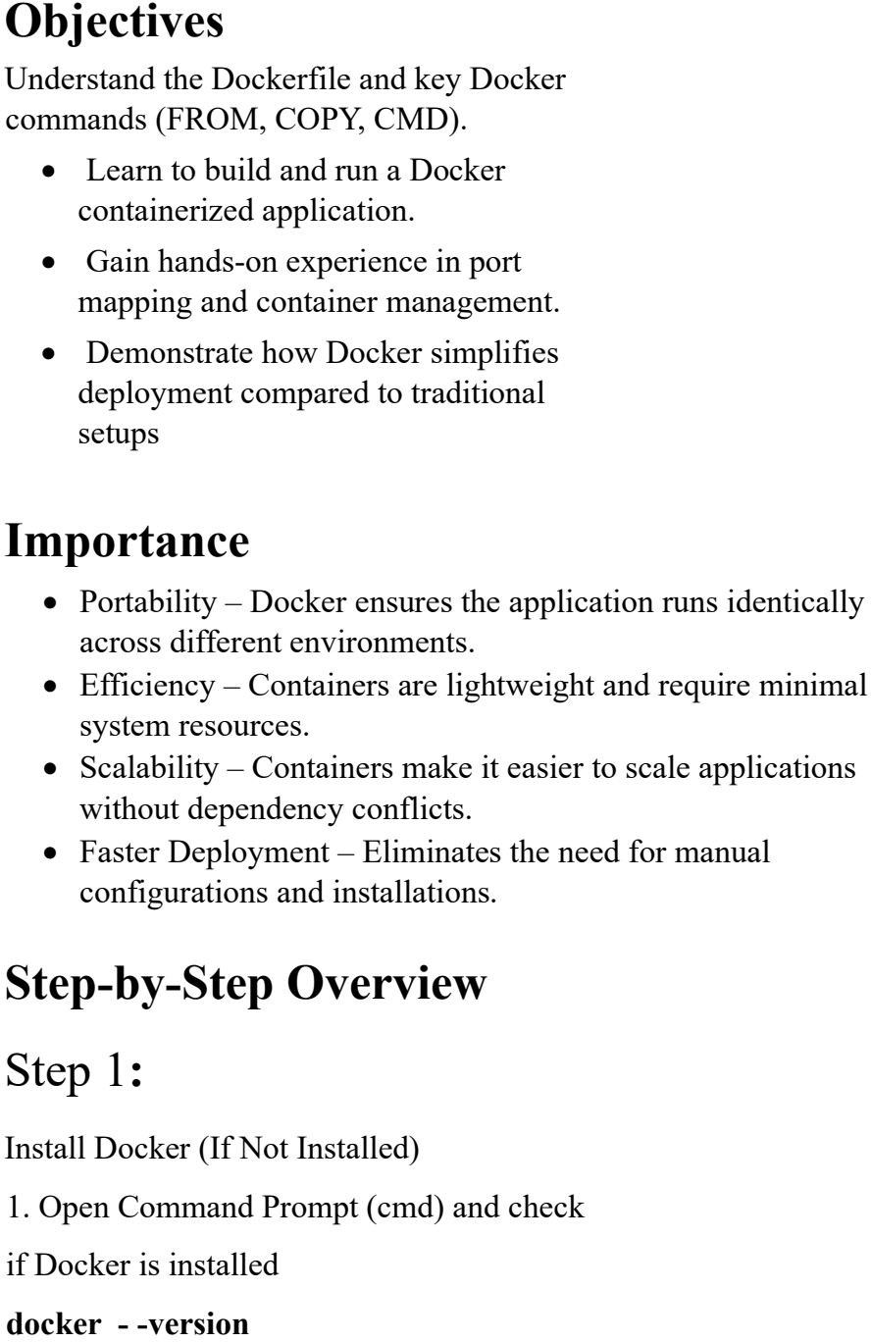

2.if not installed,download and install

Docker from docker’s official website.

3.ensure docker desktop is running before

Proceeding



STEP 2:

Create a project Directory

Open command prompt and run

mkdir my-docker-html && cd my-

docker-html

